|  |  |  |  |
| --- | --- | --- | --- |
| **Übungsprotokoll**  **SYTB – Systemtechnik Betriebssysteme** | | | |
|  | **Übungsdatum:**  KW /2021 –  KW /2021 | **Klasse:**  3AHIT | **Name:**  Felix Schneider |
| **Abgabedatum:**  dd.mm.yyyy | **Gruppe:**  SYTB_2 | **Note:** |
| **Leitung:**  DI (FH) Alexander MESTL | **Mitübende:**  - | | |
| **Übungsbezeichnung**:  Debian Server | | | |

**Inhaltsverzeichnis:**

1 Aufgabenstellung 10

1.1 Knottenbelt Lecture IV 10

2 Theoretische Grundlagen 10

2.1 Knottenbelt Lecture IV 10

3 Übungsdurchführung 10

3.1 Knottenbelt Lecture IV 10

**3.1.1** **Archive the contents of your home directory using tar. Compress the tar file with gzip. Now uncompress and unarchive the .tar.gz file using cat, tar and gzip on one command line.** 10

**3.1.2** **Use find to compile a list of all directories in the system, redirecting the output so that the list of directories ends up in a file called directories.txt and the list of error messages ends up in a file called errors.txt.** 11

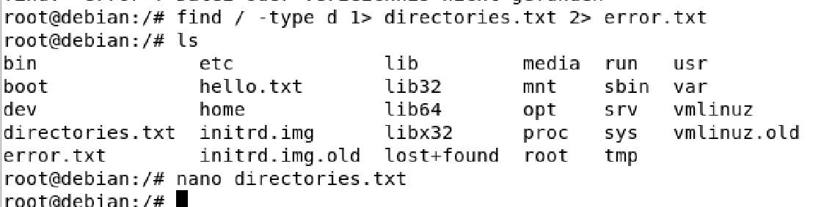 11

**3.1.3** **Try the command sleep 5. What does this command do?** 11

 11

**3.1.4** **Run the command in the background using &.** 12

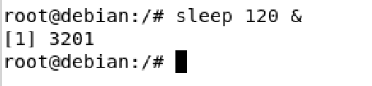 12

**3.1.5** **Run sleep 15 in the foreground, suspend it with Ctrl-z and then put it into the background with bg. Type jobs. Type ps. Bring the job back into the foreground with fg.** 12

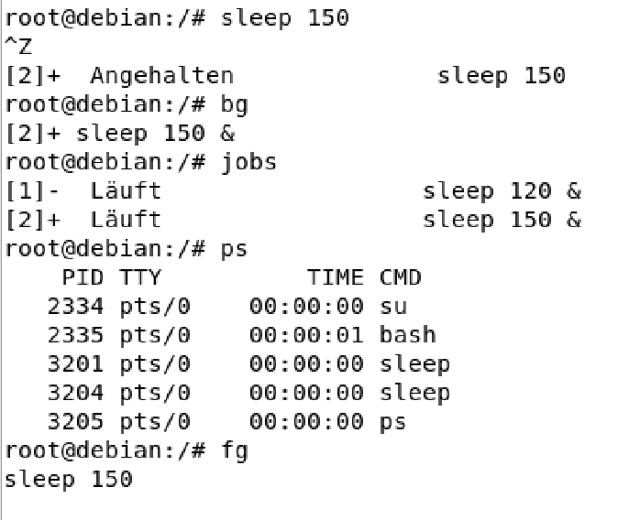 12

**3.1.6** **Run sleep 15 in the background using &, and then use kill to terminate the process by its job number. Repeat, except this time kill the process by specifying its PID.** 12

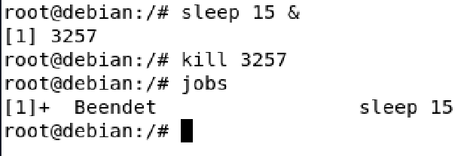 13

**3.1.7** **Run sleep 15 in the background using &, and then use kill to suspend the process. Use bg to continue running the process.** 13

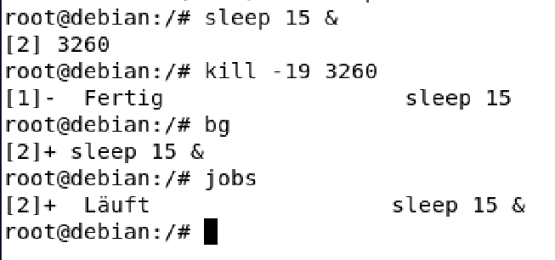 13

**3.1.8** **Startup a number of sleep 60 processes in the background, and terminate them all at the same time using the pkill command.** 13

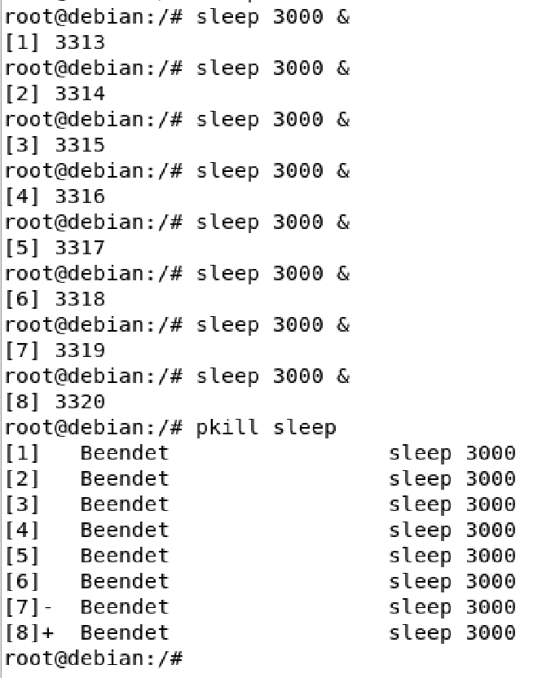 14

**3.1.9** **Use ps, w and top to show all processes that are executing.** 14

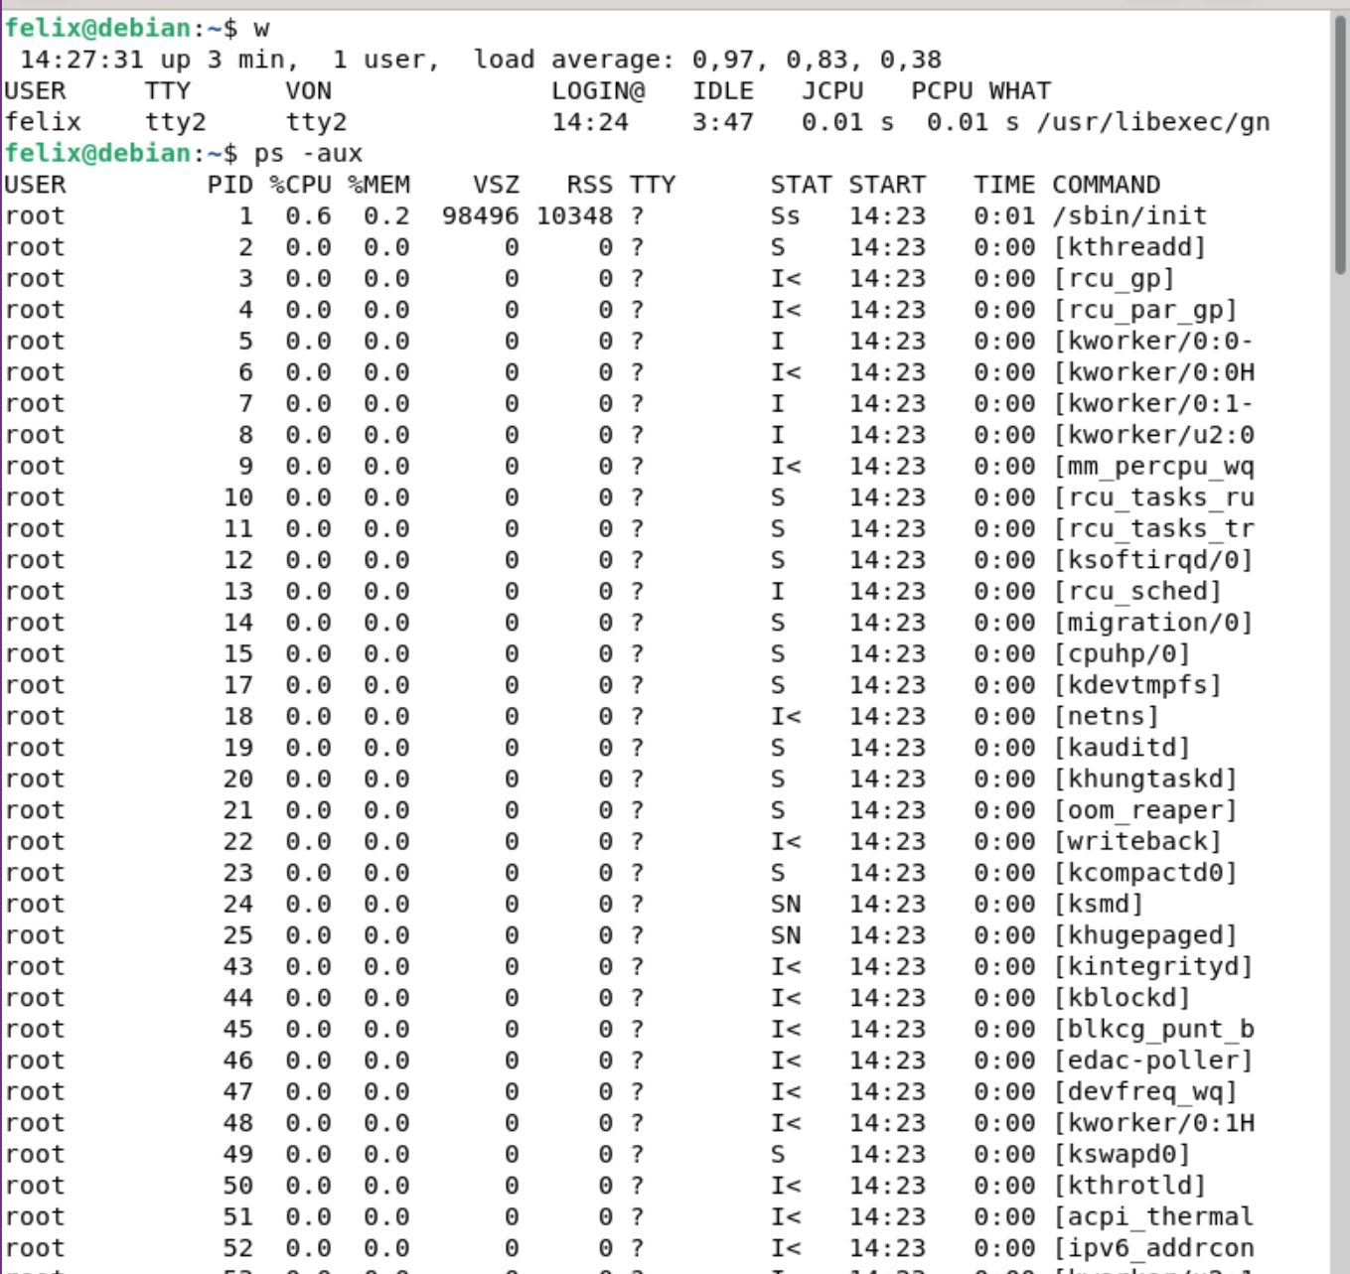 15

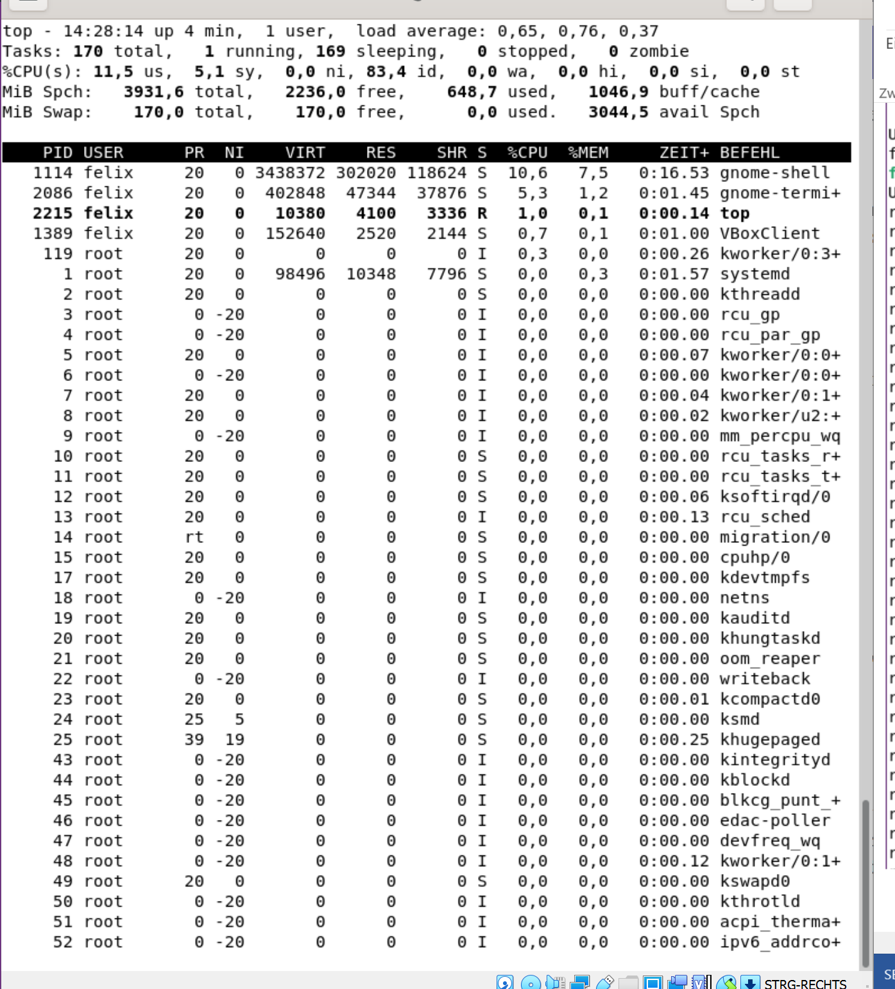 16

**3.1.10** **Use ps -aeH to display the process hierarchy. Look for the init process. See if you can identify important system daemons. Can you also identify your shell and its subprocesses?** 16

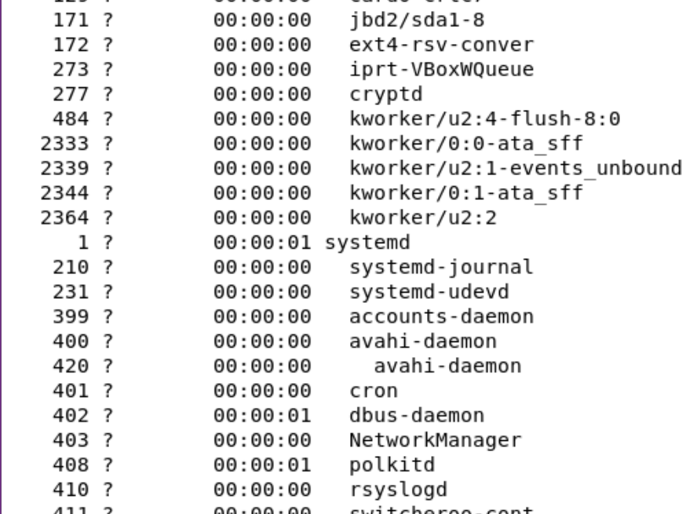 17

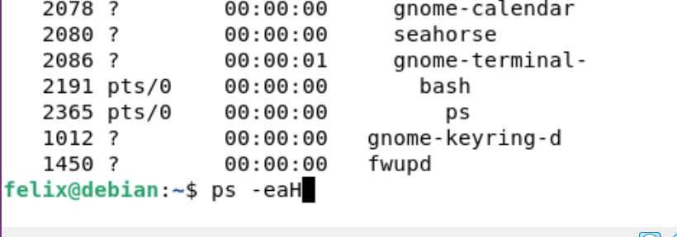 17

**3.1.11** **Combine ps -fae with grep to show all processes that you are executing, with the exception of the ps -fae and grep commands.** 18

**3.1.12** **Start a sleep 300 process running in the background. Log off the server, and log back in again. List all the processes that you are running. What happened to your sleep process? Now repeat, except this time start by running nohup sleep 300.** 18

**3.1.13** **Multiple jobs can be issued from the same command line using the operators ;, && and ||. Try combining the commands cat nonexistent and echo hello using each of these operators. Reverse the order of the commands and try again. What are the rules about when the commands will be executed?** 19

**3.1.14** **What does the xargs command do? Can you combine it with find and grep to find yet another way of searching all files in the /home subdirectory tree for the word hello?** 22

**3.1.15** **What does the cut command do? Can you use it together with w to produce a list of login names and CPU times corresponding to each active process? Can you now (all on the same command line) use sort and head or tail to find the user whose process is using the most CPU?** 22

4 Ergebnisse **Fehler! Textmarke nicht definiert.**

5 Kommentar 23

# Aufgabenstellung

## Knottenbelt Lecture IV

# Theoretische Grundlagen

## Knottenbelt Lecture IV

# Übungsdurchführung

## Knottenbelt Lecture IV

* + 1. **Archive the contents of your home directory using tar. Compress the tar file with gzip. Now uncompress and unarchive the .tar.gz file using cat, tar and gzip on one command line.**

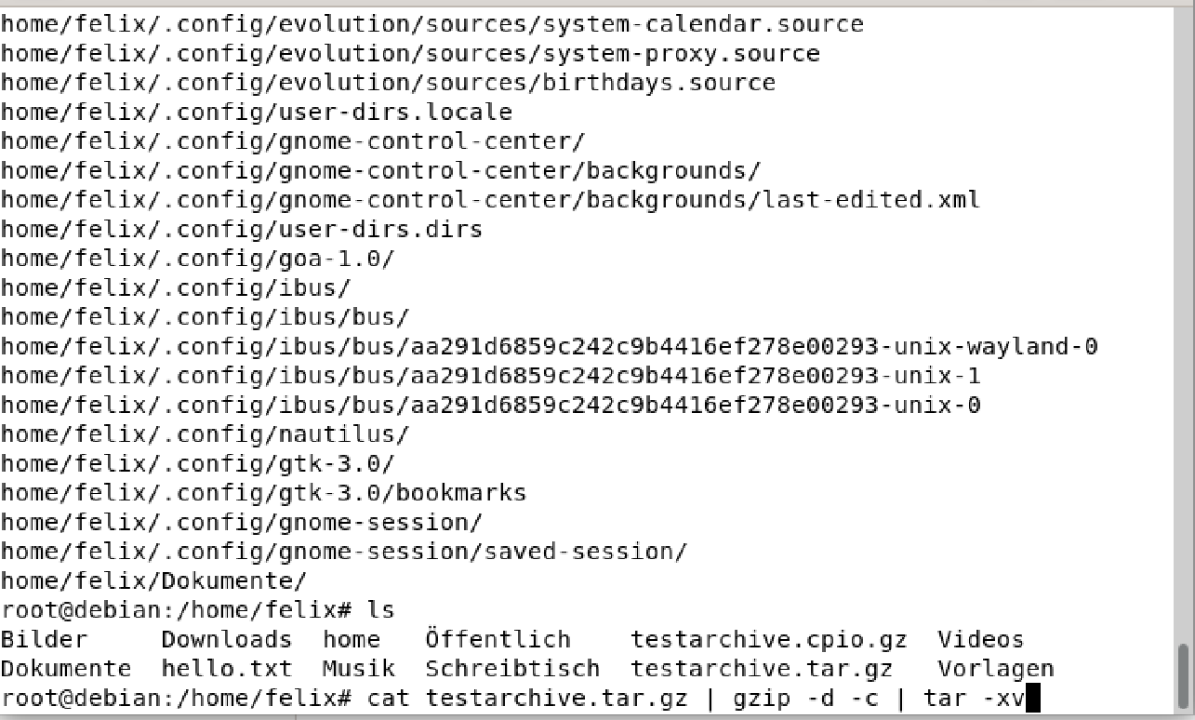

* + 1. **Use find to compile a list of all directories in the system, redirecting the output so that the list of directories ends up in a file called directories.txt and the list of error messages ends up in a file called errors.txt.**



* + 1. **Try the command sleep 5. What does this command do?**



Der Befehl lässt das Terminal für 5 Sekunden schlafen.

* + 1. **Run the command in the background using &.**



* + 1. **Run sleep 15 in the foreground, suspend it with Ctrl-z and then put it into the background with bg. Type jobs. Type ps. Bring the job back into the foreground with fg.**



* + 1. **Run sleep 15 in the background using &, and then use kill to terminate the process by its job number. Repeat, except this time kill the process by specifying its PID.**



* + 1. **Run sleep 15 in the background using &, and then use kill to suspend the process. Use bg to continue running the process.**



* + 1. **Startup a number of sleep 60 processes in the background, and terminate them all at the same time using the pkill command.**



* + 1. **Use ps, w and top to show all processes that are executing.**





* + 1. **Use ps -aeH to display the process hierarchy. Look for the init process. See if you can identify important system daemons. Can you also identify your shell and its subprocesses?**





Systemd mit der PID 1 ist der Systemdeamon und ersetzt auch den init process. Die Shell ist bash mit dem ps als subprocess.

* + 1. **Combine ps -fae with grep to show all processes that you are executing, with the exception of the ps -fae and grep commands.**

**Ein Bild, das Tisch enthält.
**

* + 1. **Start a sleep 300 process running in the background. Log off the server, and log back in again. List all the processes that you are running. What happened to your sleep process? Now repeat, except this time start by running nohup sleep 300.**

**Ein Bild, das Text enthält.
**

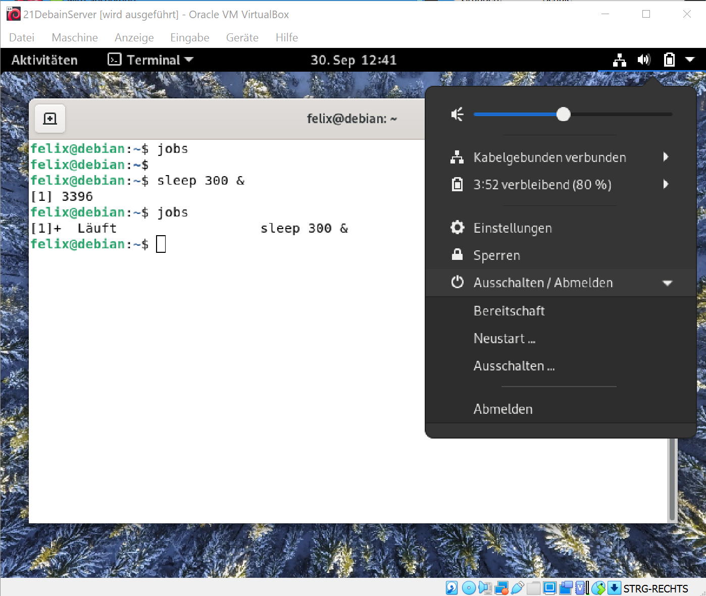

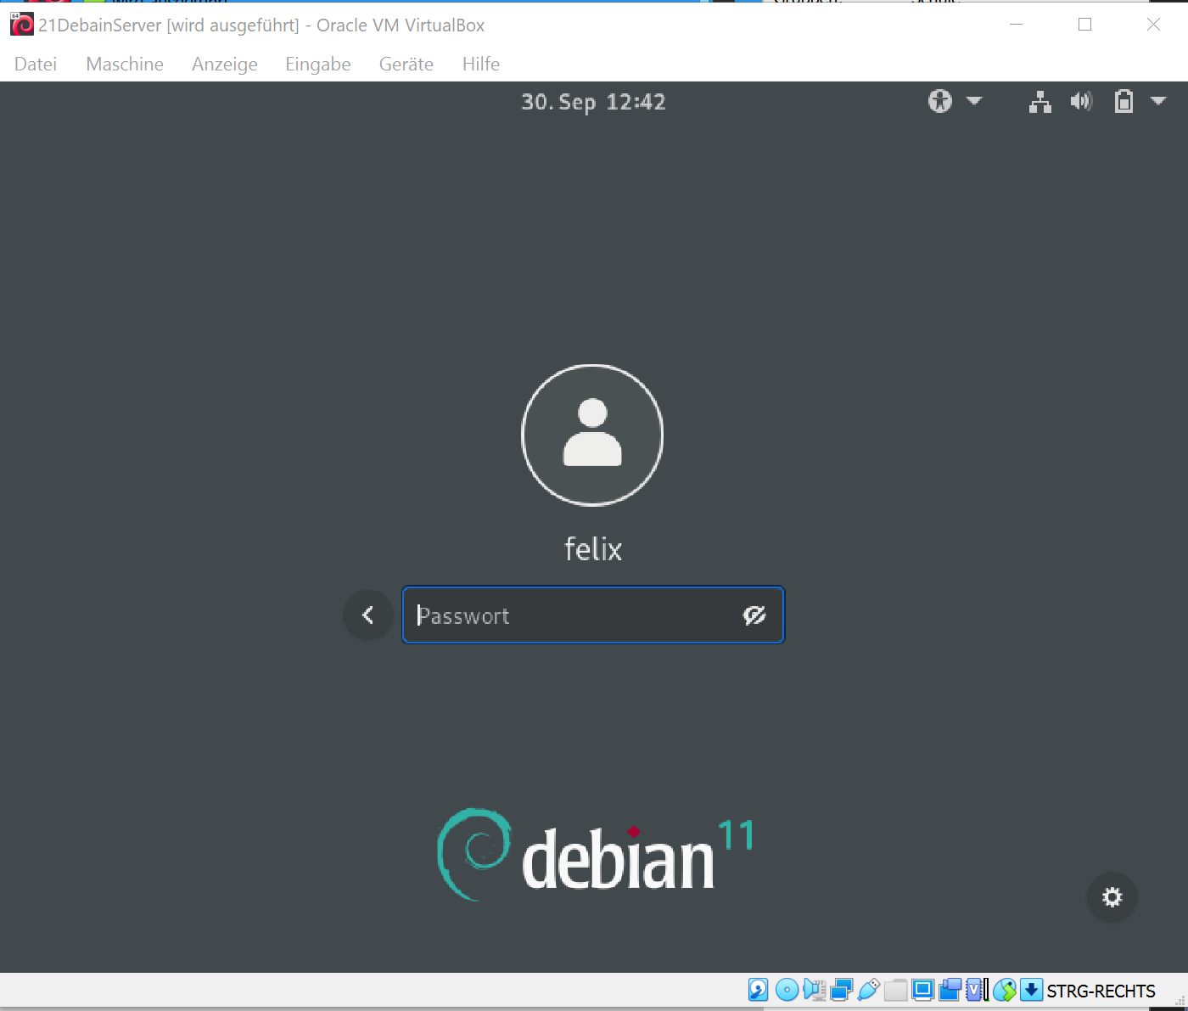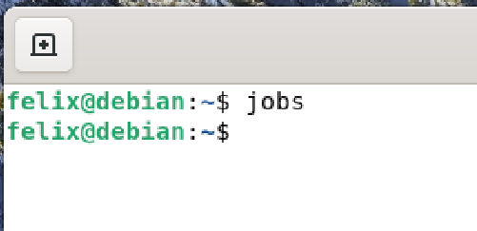

**Ein Bild, das Text enthält.
**

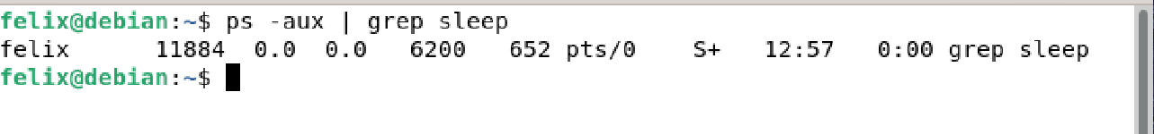Eigentlich sollte hier der Prozess sleep 3000 erscheinen, doch Gnome killt den Prozess beim Abmelden.

**Ein Bild, das Text, Tisch enthält.
**

* + 1. **Multiple jobs can be issued from the same command line using the operators ;, && and ||. Try combining the commands cat nonexistent and echo hello using each of these operators. Reverse the order of the commands and try again. What are the rules about when the commands will be executed?**

‘;’ … führt die Prozesse hintereinander aus

‘&&’ … führt den zweiten Prozess aus, wenn der erste erfolgreich war

‘||’ .. führt den zweiten Prozess aus, wenn der erste fehlgeschlagen hat

Ein Bild, das Text enthält.

* + 1. **What does the xargs command do? Can you combine it with find and grep to find yet another way of searching all files in the /home subdirectory tree for the word hello?**

**Ein Bild, das Text, Zeitung enthält.
**

* + 1. **What does the cut command do? Can you use it together with w to produce a list of login names and CPU times corresponding to each active process? Can you now (all on the same command line) use sort and head or tail to find the user whose process is using the most CPU?**

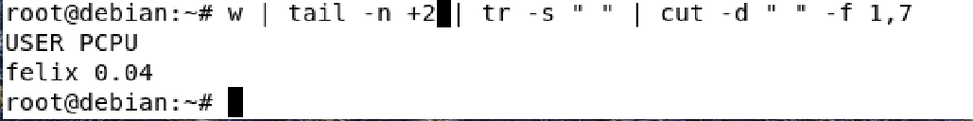

Ein Bild, das Text enthält.

# Kommentar

Diese Lecture + Exercise lehrt sehr viel über den sleep Befehl.